**Дата**: 14.03.2025

**Клас**: 5-А

**Предмет**: англійська мова

**Тема:** Мій вільний час, Повторення вивченого матеріалу.

**Мета:** формувати навички вживання лексичних одиниць по темі; удосконалювати навички читання, аудіювання й усного монологічного мовлення; розвивати пізнавальні інтереси учнів; виховувати інтерес до самостійного пошуку потрібної інформації, а також загальну культуру учнів.

**Вчитель**: Руда Д.В.

Хід уроку

1.Greeting

Good afternoon, guys! I’m pickled pink to see you. Are you ready to start our lesson? All set?

2. Повторення

Повторити Irregular verbs .

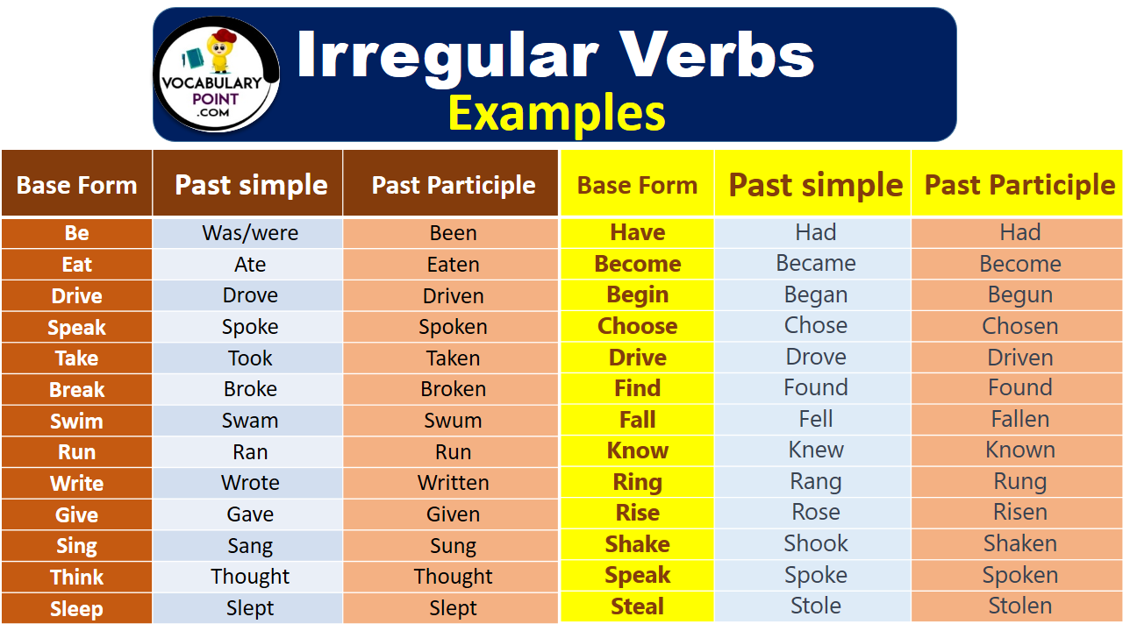

***Вивчити словник (бути готовим до слоникового диктанту) :***

*Careful-обережно (кеафул)*

*Slippery-слизько (сліпері)*

*To put on- одягати (пут он)*

*Overcast: covered with clouds; no sun is visible.- похмуро, сонця нема (овекаст)*

*"Under the weather": feeling ill or in low spirits. (e.g., "I'm feeling a bit under the weather today, so I'll stay home from work.")- мати погане самопочуття ( анде за везе)*

.

*Drizzle-мряка(дрізл)*

*Showers- a [short](https://dictionary.cambridge.org/dictionary/english/short" \o "short) [period](https://dictionary.cambridge.org/dictionary/english/period" \o "period) of [rain](https://dictionary.cambridge.org/dictionary/english/rain" \o "rain) or [snow](https://dictionary.cambridge.org/dictionary/english/snow" \o "snow)*

*Downpour- a lot of [rain](https://dictionary.cambridge.org/dictionary/english/rain" \o "rain) in a [short](https://dictionary.cambridge.org/dictionary/english/short" \o "short) [time](https://dictionary.cambridge.org/dictionary/english/time" \o "time) (дайн пор)*

*Flood-повінь(флад)*

*Hail-град(хейл)*

*Sleet-мокрий сніг(сліт)*

*Snowflake-сніжинка(сноуфлейк)*

*Blizzard-хуртелиця (блізард)*

*Mild: moderate in temperature; neither hot nor cold- помірний, м’який (майлд)*

*"Every cloud has a silver lining": every bad situation has some positive aspect to it. (e.g., "I lost my job, but I found a better one soon after. Every cloud has a silver lining.")- нема лиха без добра( ідіома)*

*To expect-очікувати(експект)*

*To report-повідомити(ріпот)*

*Chilly-прохолодний(чілі)*

*To get cold-холоднішати*

*It`s raining cats and dogs-сильно дощити (ідіома)*

*They cancelled the football game because it was raining cats and dogs.*

*puddle-калюжа (падл)*

*precipitation-опади (прісіпітейшн)*

*partly cloudy- мінлива хмарність (патлі клауді)*

*to be below freezing- бути нижче нуля*

*bitterly cold- дуже холодно*

*a blanket of snow-сніговий покрив*

*boiling hot- дуже спекотно*

*changeable-мінлива*

*a change in the weather- зміна погоди*

*clear blue skies- чисте блакитне небо, без хмар*

*to clear up-прояснятися*

*to come out (the sun)- виходить сонце із-за хмар*

3. Wаrm up / Listening

Уважно слухати аудіо трек і дати відповідь на питання вчителя <https://www.youtube.com/watch?v=8JVP89wrLMU> .

4. Speaking

Do you have enough free time?

Do you have free time on Sundays?

Do you have much free time during the day?

Do you have much free time in the evenings?

Do you have much free time in the mornings?

Do you like to watch movies? (...like to play tennis, ...)

What are you doing this weekend?

What did you do last summer vacation?

What did you do last weekend?

What do you do in your free time?

What hobbies do you have?

When do you have free time? (How do you spend your free time?)

Where do you spend your free time?

Who do you spend your free time with?

How do you like to spend your free time?

going shopping? going to the cinema? chatting? playing computer games going to the disco? playing sports?reading? relaxing?

If you had more free time, what would you do with it?

Tell me about some good places to hang out.

Why are they good?

Where do young people in this country usually spend their free time?

Would you like to have more free time?

What would you like to give up so that you could have more free time?

How do the women in your family usually spend their free time?

How do the men in your family usually spend their free time?

Do men and women spend their free time differently? How?

If it were suddenly announced that tomorrow was a national holiday, what would you do?

What do you do on Saturdays?

Do people's leisure time activities change as they get older? How?

Who do you like to spend your leisure time with?

What do you usually do?

Do you like gossiping in your free time?

Who do you gossip with?

Who do you gossip about?

What do you really hate having to do in your free time?

What new activity would you like to try doing in your free time?

Do you ever feel that you waste your free time? How?

What can you do about this?

Do you find that your works or studies takes up your free time?

Are there any activities that you used to do but don't do anymore?

Why did you stop?

5. Writing

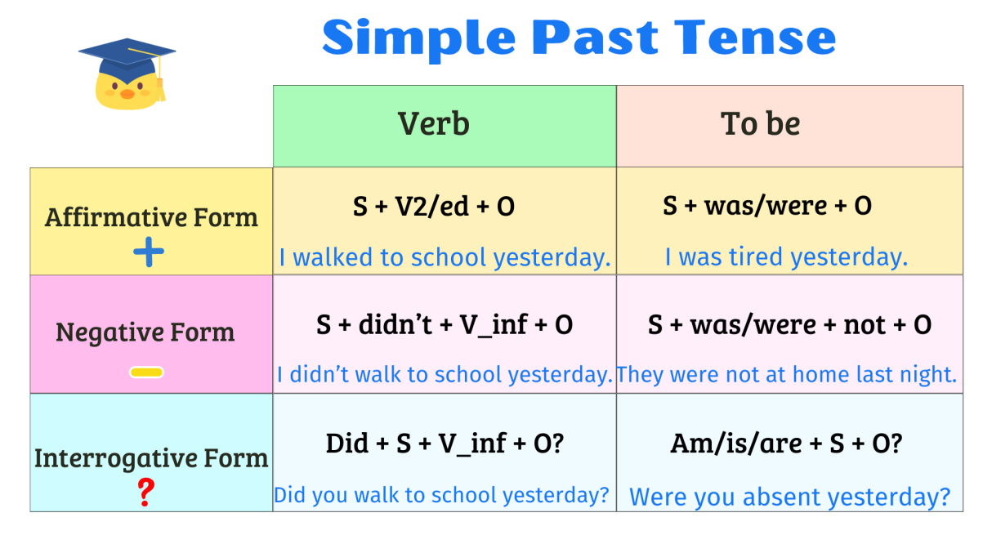

Повторити past simple.

<https://www.liveworksheets.com/w/en/english-second-language-esl/1243112>

6. Homework

1. Виконати вправу письмово . (повторення )

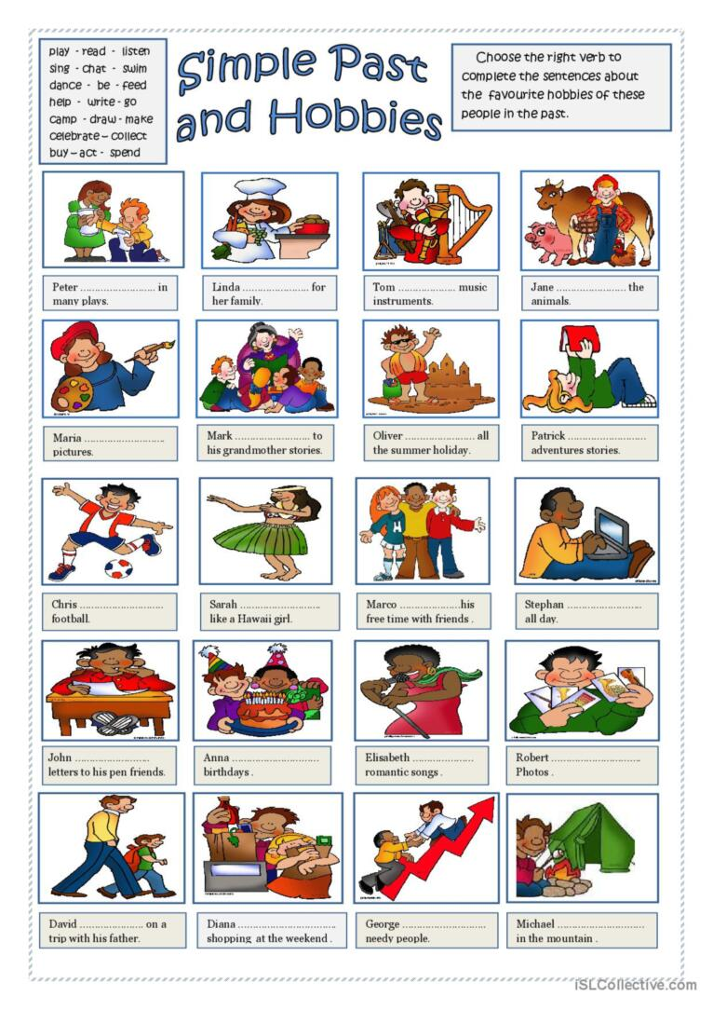

2. Повторити слова в словнику та вивчити нові слова на стр 93.